# Dataflow Structure

Wartsila software supply contains many different items, installed in two control centres on different servers. General approach is next: different VTS sensors connects to dedicated software installed on sensor servers (AIS, RDF, CCTV), VTS server gathers all sensor data, processes it and send to Operator workstations.

Figure 4‑1 –General Data flow diagram

Radar is connected to radar processor server. There are 2 peace of software installed on radar processor server: ORS server and VARP. ORS server manages radar control and diagnostic. VARP manages radar video. Navi Harbour ODU 0 connects to ORS Server and VARP and distribute control and video to Navi Harbour ODUs installed on Operator workstations

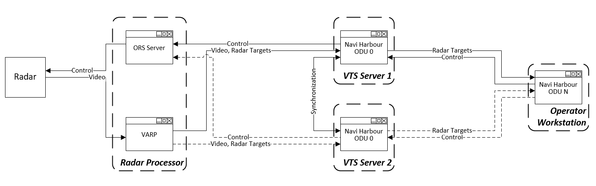

Figure 4‑2 –Radar Data flow diagram

AIS base station is connected to AIS server. There is AIS BSC software installed on AIS server. AIS BSC manages AIS messages and diagnostic. Navi Harbour ODU 0 connects to AIS sever and distribute AIS messages to Navi Harbour ODUs installed on Operator workstations

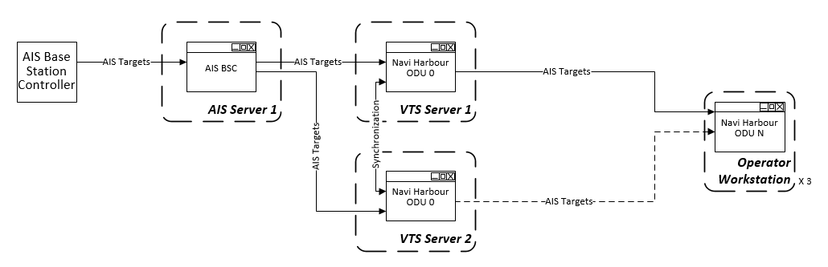

Figure 4‑3 –AIS Data flow diagram

VHF radio stream is connected to Data storage server. There is Voice Recording server installed on Data storage server. Voice Recording server manages reception of VHF radios stream. Navi Harbour ODU 0 connects to Voice Recording Server and distribute audio data to Navi Harbour ODUs installed on Operator workstations.

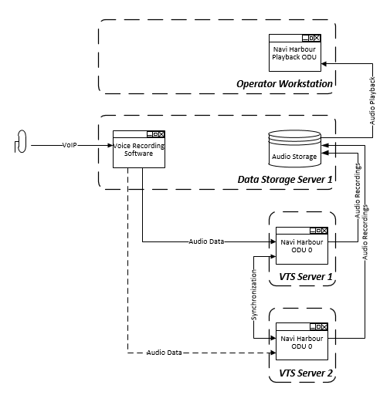

Figure 4‑4 –VHF radio Data flow diagram

CCTV camera is connected to Sensor server for control and to the Video Recording server for video stream. There is CCTV server installed on Sensor Server and CCTV recording software installed on Video recording server. CCTV server manages camera control. CCTV recording software manages video stream recording and distributing. Navi Harbour ODU 0 connects to CCTV Server control to Navi Harbour ODUs installed on Operator workstations. CCTV video recording software distributes online and recorded video to CCTV Viewers.

Figure 4‑5 –CCTV Data flow diagram

Weather station data is connected to Sensor server. There is Hydrometeo Server software installed on Sensor server. Hydrometeo Server manages weather messages. Navi Harbour ODU 0 connects to Hydrometeo Server and distribute wheather data to Navi Harbour ODUs installed on Operator workstations

Figure 4‑6 –Weather Data flow diagram

Used port

TCP Ports used in internal data exchange are listed in the table:

|  |  |
| --- | --- |
| **TCP Port** | **Software** |
| 2000 | Navi-Harbour |
| 2000 | Record Server |
| 7500 | CCTV Server |
| 4000 | DF Server |
| 8198 | HM Server |
| 8196 | Global Integrator |
| 8000  8001  8002  8004 | ORS Server |
| 8201 | Sound Server |
| 8040  8042  8044 | AIS BSC |
| 8199 | Target Exchange Server |

### Disaster recovery

All main software components are redundant and have flexible configuration. Two control centers have identical set of servers and can work together or independently.

There are main and backup VTS server in each control center. VTS servers ping each other to check status. In case of main server failure, backup server become active. Configuration is synchronized between all VTS servers in both control centers. Operator workstation connects to active VTS server in own Control center.

There are main and backup Database servers in each control center. There is a replication, made by MS SQL, between all Database servers. VTS servers ping Database servers in own control center to check status. In case of main Database server failure, backup Database server become active.

There are a VTS recording servers in each control center. Active VTS server provide data to own VTS recording server. VTS Workstations get data from VTS recording server in own control center.

Sensors are connected to corresponding sensor server (AIS server, CCTV server, RDF server) in closest control center. In case of sensor server failure sensor application can be launched in other control center manually.

Figure 4‑7 –VTS server redundancy diagram 1

There are one video recording servers in each control center. Servers connect to CCTV cameras to get video stream. Video recording servers work independently. Operator workstations connect to video recording server in own control center.

There is one network monitoring server in each control center. There is a synchronization between servers. Operator workstation connect to network monitoring server in own control center

Figure 4‑8 –VTS server redundancy diagram 2

### Bandwidth requirements

There are tables with bandwidth requirement for each site:

### PMIS integration

VTS shares target data with PMIS. AIS BSC sends AIS stream to PMIS application using NMEA protocol. It is possible to send combined AIS stream from all necessary AIS sources.

Figure 4‑9 –PMIS Integration